Luton Technology(LT) is going develop Business Bargain’s(BB) web-application which will be used only for online auctions and payment related tasks. The whole project is designed to be developed using DSDM Atern framework since it uses some flexible techniques by keeping quality, time and cost in prime concern. It only works with the actual business requirements of the project with customer’s involvement from planning throughout deployment.

**Task-1**

* The eight principles of DSDM Atern and their evaluation for this project are described as follows:

1. **Focus-on-the-business-need:**

The main goal of this principle is to stay focused with the main business objectives throughout the project within right time and price (DSDM Consortium, 2010). Therefore, all the focus for this project will be developing an online auction web-application for BB within allocated resources.

1. **Deliver-on-time**

Delivering a project on time is the primary outcome for a project and is solely most important factor (Agile Business Consortium Limited, 2014). BB-web-application will also be developed using Timeboxes so that the project is delivered on time.

1. **Collaborate**

A failed project has no winner. Therefore, DSDM-Atern needs to involve right skilled people with clear roles (DSDM Consortium, 2010). In this project, skilled people will be hired and adopted from BB with their clear roles and responsibilities so that they can cooperate and honor each other’s commitments.

1. **Never-Compromise-quality**

DSDM Atern always aims for the quality that was agreed at the start of the project. DSDM believes that the solution should be good enough with business needs to run smoothly (Agile Business Consortium Limited, 2014). With a view to maintain the agreed quality, all the developed solutions of BB-web-application will be tested properly with constant review (DSDM Consortium, 2010, pp. 13-15).

1. **Build-incrementally-from-firm-foundations**

DSDM follows enough design up front (EDUF) concept for the solution development as it mitigates risk of project failure. It focuses on incremental development. No sooner had the MoSCoW-prioritization is applied, BB-web-application will be started with primary requirements considering EDUF concept (DSDM Consortium, 2010, pp. 13-15).

1. **Develop-iteratively**

DSDM believes that rarely anything is created perfectly for the first time and changes are common. To embrace these changes the team converge on an accurate business solution (Agile Business Consortium Limited, 2014). BB web application will also be developed bearing the probability of changes since the world is changing and it is natural through a project life-cycle.

1. **Communicate-continuously-and-clearly**

DSDM practices are meant for the effectiveness of since poor communication often causes project failure (DSDM Consortium, 2010, pp. 13-15). During the life-cycle of BB-web-application development face-to-face communication, daily team stand-up sessions, prototyping, demonstration and documentation will be maintained (Agile Business Consortium Limited, 2014).

1. **Demonstrate-control**

A DSDM-Atern team needs to be proactive for monitoring and controlling the progress so that the project is always under control (DSDM Consortium, 2010, pp. 13-15). For BB project the team will continuously evaluate project viability based on the business objectives.

* In order to reinforce user and managerial feedback some team members are adopted from the customers who will take part during feature prioritization and help the SDT. After each development, they will give their review to the product. During workshop session they will review and advice. Besides, user and managerial feedback could be more effective during QA sessions.
* In traditional approach, delivering functions of a project are controlled and monitored by the detailed plan. Therefore, the end result was “quick and dirty” by losing robustness. On the contrary, DSDM-Atern believes that changes may happen. Therefore, it uses Iterative development by strictly maintained Timeboxes without compromising the quality to the actual business needed features, rather than unnecessary features unlike traditional approach (DSDM Consortium, 2010, p. 8).

**Task-2**

The BB-web-application requires to be easy to use for both the customers and BB staff’s. Therefore, several specified person needs to be hired. Among them four hypothetical people are defined:

1. **Web-Designer:**

For the sake of easy BB-web-application’s user interaction, experienced web designer needs to be hired. He or she is responsible to make the project visible to the users.

**Skills:**

1. Must be expert on UX/ UI design.
2. Must have good communication skill.
3. Must be able to make responsive design.
4. Excellent analytical and problem-solving skill.

**Experiences:**

Minimum 3 years of working experience.

**Weight of contribution:**

Needs to work as part time.

1. **Solution-developer:**

Solution developer makes the logical developments of the solutions. For BB-web-application, expert solution-developer needs to be recruited.

**Skills:**

1. Must have strong programming knowledge with PHP, JavaScript.
2. Should have strong verbal and communication skills.
3. Must have excellent analytical and project management skills.
4. Must have excellent problem solving.

**Experiences:**

Must have 4 years of working experience.

**Weight of contribution:**

Must be available for full-time work.

1. **Workshop-Facilitator:**

Workshop Facilitator manages the workshop process beside catalyzing for preparation and communication. However, he is not responsible for the content rather than context (DSDM Consortium, 2010).

**Skills:**

1. Expert in planning workshop process.
2. Good communication skill.
3. Expert in identifying similarities and differences between statements.
4. Expert in ensuring facility to meet workshop objectives.

**Experiences:**

Must have minimum of 3 years working experience.

**Weight of contribution:**

Should be available as part-time staff.

1. **Business-Analyst:**

A Business-analyst ensures that the solution meets proper business needs. Active involvement of Business-Analyst results ultimate success of DSDM project. He stablishes the communication between other team members of solution-development-team (DSDM Consortium, 2010).

**Skills:**

* + 1. Expert in analyzing problems and developing solutions.
    2. Expert in verbal communication and written skills.
    3. Able to interpret business requirements properly.
    4. Able to understand day-to-day business implication progress.

**Experiences:**

Minimum 3 years of working experience.

**Weight of contribution:**

Full-time working staff.

**Task-3**

**Business-Ambassador** is the prime decision-maker as a representative of the business and a person who is respected through-out the organization. A Business Ambassador informs the business needs to the solution development team. He or she is able to balance their insufficient knowledge by bringing the business advisors assistance if required (2019 Agile Business Consortium Limited, 2014). They are responsible for:

* + Requirements categorization, design and review sessions.
  + Providing business scenarios detail.
  + Involving users if needed.
  + Providing solution acceptance reports.
  + Creating documentation of the project.
  + Ensuring proper users training.
* Among the four people **Vasil-Dimitrov** is the perfect candidate for the role of Business-Ambassador.
* Reasons for choosing **Vasil-Dimitrov**:

1. He is a high level staff with 12 years of working experience.
2. He has good knowledge of organizing product lots for auction.

* Reason of not choosing candidates:

1. **Stuart-Alexander:** He is the CEO of the company and is very busy with the business.
2. **Joe-Gershwin:** He is still learning the basic aspects of the company.

**Task-4**

Business ambassador, business analyst, web designer, solution developer, solution tester and business visionary are mainly involved roles in all solution development. The development progresses in several iterative sprints. The iteration of each sprints goes as follows:

**Annotated-Diagram-(Kick-off-solution):**

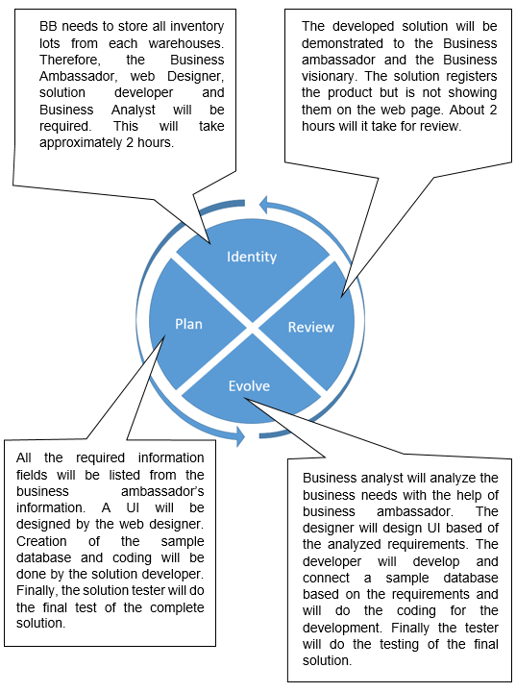

Diagram : Annotated-Diagram-of-solution-kick-off

**Annotated-Diagram-(Iterative-development):**

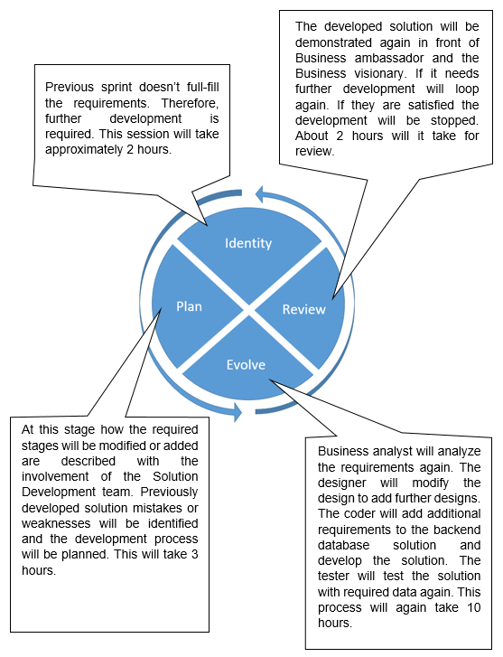

Diagram : Annotated-diagram-of-Iterative-development

**Task-5**

The project is assumed to be completed within 6 months or 24 weeks. However, the feasibility, foundation and deployment will take about one and half months or 6 weeks. Therefore, the actual development will have 4 and a half months. Moreover, after applying MoSCoW-Prioritization technique to the key deliverables the result is as follows:

|  |  |  |
| --- | --- | --- |
| **Serial-No:** | **Feature-list** | **MoSCoW-Prioritization** |
| 1 | Store the details of all inventory/ auction lots currently held in each of the three warehouses | Must Have |
| 2 | Store the details of when each lot will be auctioned | Should Have |
| 3 | Store details of the cost to purchase each auction lot | Could Have |
| 4 | Store details of sold auctions lots including the purchaser, price achieved and transport costs | Could Have |
| 5 | Store the sales method for each auction lot – online or in person | Must Have |
| 6 | Store the sale type for each auction lot – highest bid or Buy It Now | Must Have |
| 7 | Analyze business liquidation stock for suitable purchases based on previous sales, demand for products available, purchase price and transport costs to get the stock | Won’t have this time |
| 8 | Allocate purchasing staff to negotiate deals which the software has identified as meeting BBs profit margin requirements | Won’t have this time |
| 9 | Allocate warehouse staff to handle deliveries, open viewings, and getting lots ready for auction. | Must have |
| 10 | Allocate auctioneers for live auctions | Must Have |
| 11 | Allow customers to register on the website | Must Have |
| 12 | Allow customers to view photos and videos of auction lots via the website. | Should Have |
| 13 | Allow customers to submit Buy It Now offers | Should Have |
| 14 | Allow customers to bid online during the live auctions | Must Have |
| 15 | Allow customers to make online payments for successful bids | Must Have |
| 16 | Allow customers to choose suitable delivery times for successful purchases | Could Have |

* **Timeboxing**: The development for the project will have 20 weeks. Each timebox for this project should be 2 weeks long. Therefore, the number of timebox for the project will be 9.
* **Estimates**: The solution development team for this project requires 6 people. Even though, the working hour is 8 hours long but 6 working hour is assumed for each team member since there might have some preparations. Therefore, each member will have 60 working hours during a timebox and the whole team will have 360 working hours during a timebox.

“Planning Poker” technique has been applied for the Timeboxing of the project where Fibonacci numbers are applied to Identify the workload of each timebox.

|  |  |  |  |  |  |  |  |
| --- | --- | --- | --- | --- | --- | --- | --- |
| **Serial-no** | **Feature-list** | **MoSCoW-Prioritization** | **Size** | **Task-list** | **Responsible-roles** | **Effort(Man-hour)** | **Total effort(Man-hour)** |
| **Time-Box-1** | (Allow customers to register on the website) | Must Have | **18** | Know BB’s requirements for registration process | Business-Ambassador | 20 | 220 |
| Analyze Registration Process | Business-Analyst | 50 |
| Design-Registration-Form | Web-Designer | 60 |
| Implementing solution | Solution-Developer | 60 |
| Testing The solution | Solution-Tester | 30 |
| **Time-Box-2** | (Store the details of all inventory/ auction lots currently held in each of the three warehouses) | Must Have | **18** | Identify fields and process of inventory/ auction lots. | Business-Ambassador | 20 | 250 |
| Analyze fields and process | Business-Analyst | 50 |
| Design-UI | Web-Designer | 60 |
| Implementing-solution | Solution-developer | 60 |
| Testing the solution | Solution-tester | 60 |
| **Time-Box-3** | (Allocate warehouse staff to handle deliveries, open viewings, and getting lots ready for auction.) | Must Have | **13** | Identify admin field requirements | Business-Ambassador | 30 | 260 |
| Analyze admin panel requirements | Business-Analyst | 50 |
| Design admin panel | Web-Designer | 60 |
| Implement solution | Solution-developer | 60 |
| Test the solution | Solution-tester | 60 |
| **Time-Box-4** | (Store the sales method for each auction lot – online or in person.)  (Store the sale type for each auction lot – highest bid or Buy It Now.)  (Allow customers to submit Buy It Now offers) | Much Have | **13** | Analyze the sales methods and type | Business Analyst | 30 | 210 |
| Design-UI | Web-Designer | 60 |
| Develop the solution | Solution-Developer | 60 |
| Test-the-developed-solution | Solution-tester | 60 |
| **Time-Box-5** | (Allocate auctioneers for live auctions) | Must Have | **18** | Analyze the live auction requirements. | Business Analyst | 40 | 220 |
| Design-the-auction-UI. | Web-Designer | 60 |
| Develop-the-solution | Solution-Developer | 60 |
| Test-the-developed-solution | Solution-tester | 60 |
| **Time-Box-6** | (Allow customers to bid online during the live auctions)  (Allow customers to make online payments for successful bids) | Must Have | **21** | Analyze-business-requirements-for-live-auction | Business Analyst | 50 | 220 |
| Design-auction-UI | Web-Designer | 60 |
| Develop-the-solution | Solution-Developer | 60 |
| Test-the-developed-solution | Solution-tester | 50 |
| **Time-Box-7** | (Store the details of when each lot will be auctioned)  (Allow customers to view photos and videos of auction lots via the website.) | Should have | **13** | Analyze-requirements-for-view. | Business Analyst | 40 | 220 |
| Design-UI | Web-Designer | 60 |
| Develop-solution | Solution-Developer | 60 |
| Test-the-developed-solution. | Solution-tester | 60 |
| **Time-Box-8** | (Store details of the cost to purchase each auction lot)  (Allow customers to choose suitable delivery times for successful purchases) | Could Have | **8** | Analyze the business requirements. | Business Analyst | 40 | 200 |
| Design-UI | Web-Designer | 60 |
| Develop-the-solution | Solution-Developer | 60 |
| Test-the-developed-solution | Solution-tester | 40 |
| **Time-Box-9** | (Store details of sold auctions lots including the purchaser, price achieved and transport costs) | Could Have | **8** | Analyze the requirements | Business Analyst | 40 | 190 |
| Design-required-UI | Web-Designer | 60 |
| Develop-the-solutions. | Solution-Developer | 60 |
| Test-the-developed-solutions. | Solution-tester | 30 |

* **Expected-sprints:**

Timebox and developed feature(s):

|  |  |
| --- | --- |
| **Serial-No:** | **Features-List** |
| **TimeBox-1** | * Allow customers to register on the website |
| **TimeBox-2** | * Store the details of all inventory/ auction lots currently held in each of the three warehouses |
| **TimeBox-3** | * Allocate warehouse staff to handle deliveries, open viewings, and getting lots ready for auction. |
| **TimeBox-4** | * Store the sales method for each auction lot – online or in person. * Store the sale type for each auction lot – highest bid or Buy It Now. * Allow customers to submit Buy It Now offers |
| **TimeBox-5** | * Allocate auctioneers for live auctions |
| **TimeBox-6** | * Allow customers to bid online during the live auctions * Allow customers to make online payments for successful bids |
| **TimeBox-7** | * Store the details of when each lot will be auctioned * Allow customers to view photos and videos of auction lots via the website. |
| **TimeBox-8** | * Store details of the cost to purchase each auction lot * Allow customers to choose suitable delivery times for successful purchases |
| **TimeBox-9** | * Store details of sold auctions lots including the purchaser, price achieved and transport costs |

All the timeboxes are designed according to the dependency of the features and their priority. For instance, user registration and storing inventory items are designed to be developed first. This is because, without these features there will be no customers and no auction lots to be checked or developed such as live biding or live auction.

Expected sprints for each timebox:

|  |  |
| --- | --- |
| **Time-Box(s)** | **Number of Sprints** |
| Timebox-1 | 3 |
| Timebox-2 | 3 |
| Timebox-3 | 3 |
| Timebox-4 | 4 |
| Timebox-5 | 2 |
| Timebox-6 | 4 |
| Timebox-7 | 3 |
| Timebox-8 | 2 |
| Timebox-9 | 2 |

* **Anticipated-deliverables:**

The final product after each Timebox will be:

|  |  |
| --- | --- |
| **Serial-No:** | **Features-List** |
| **TimeBox-1** | Customer will be able to register successfully. |
| **TimeBox-2** | All three warehouse staffs will be able to store inventory/ auction lots details. |
| **TimeBox-3** | Warehouse staffs will be able to handle deliveries, open viewings and getting lots ready for auction. |
| **TimeBox-4** | * Sales method for each auction lot could be stored. * Highest bid or Buy it now sale type for lot could be stored. * Customers could submit Buy It Now offers. |
| **TimeBox-5** | * Auctioneers could allocate live auctions |
| **TimeBox-6** | * Customers will be able to bid online during the live auctions * Customers will be able to make online payments for successful bids |
| **TimeBox-7** | * Details for each auction lots schedule could be stored. * Customers could view photos and videos of auction lots via the website. |
| **TimeBox-8** | * Each auction lot purchase details could be stored. * Customers could choose suitable delivery times after successful purchases |
| **TimeBox-9** | * Sold auctions lots details including the purchaser, price achieved and transport costs could be stored. |

* **Project-Approach-Questionnaire:**

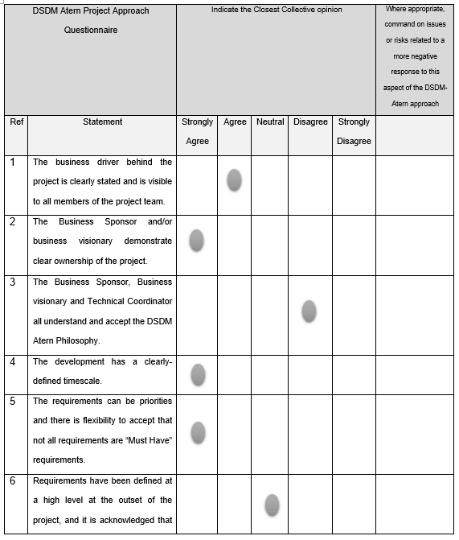

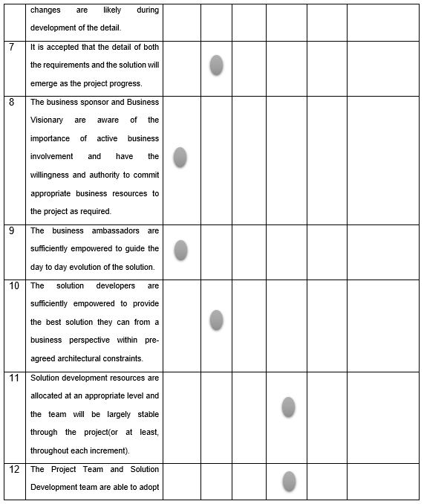

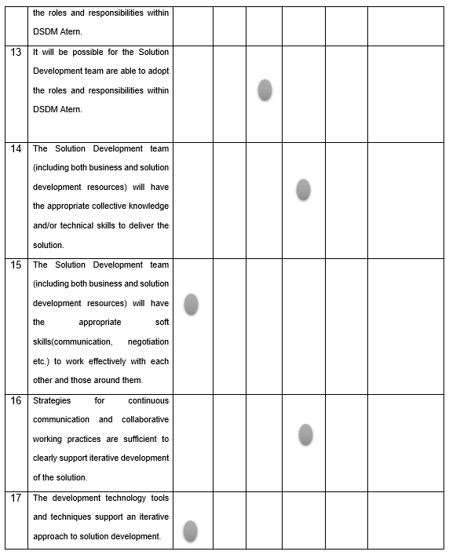

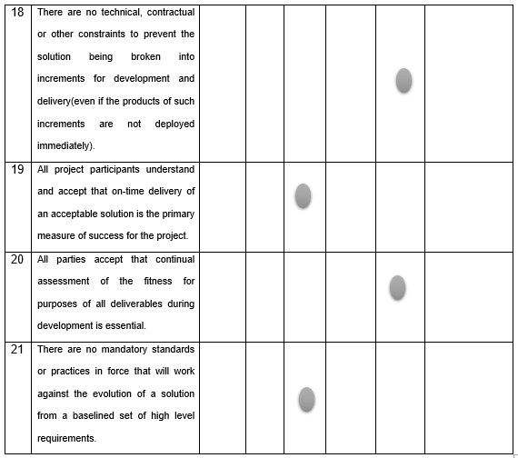

Finally, since BB web-application is going to do the online auction, therefore the only features that are related for this project are designed to develop using DSDM Atern. DSDM Atern do user involvement with strictly time and quality management throughout the project. It lets the users to easily adopt changes. Among other agile methodologies DSDM has many rich techniques that mitigates the risk in a great margin.